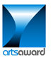
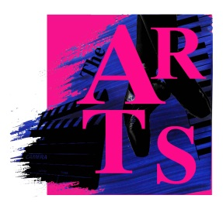
ARTS AWARD CELEBRATIONS!
The Arts Award supports young people to develop arts knowledge, creativity, communication skills, and have the ability to lead projects.
The following students have achieved their Bronze Arts Award:
Nyah Brooks, Ellie Slater, Lucy Montefiore, Anna Shellswell, Ip Lung-Yee, Lily Kennedy, Natasha Ashbridge, Milly Dove, Katie Burnett, Tia Perkins
Molly Vines, Dory Georgieva, Joseph Heber-Percy, Anna Oliver, Amy Ayres, Gemma Howard, Victoria Booth, Emma Bird

The following students have achieved their Silver Arts Award:
Alex Beville, Zoe Bulsara, Max Brown, Bella Hutton, Molly Ingman, Alex Knighton, Charlie Major, Emily Montefiore
The moderator from Trinity was very complimentary about the work the students had produced and that the portfolio’s were presented with real attention to detail and demonstrated a huge engagement
A HUGE CONGRATULATIONS TO THE ABOVE STUDENTS IN THEIR ACHIEVEMENT
Mrs Spokes
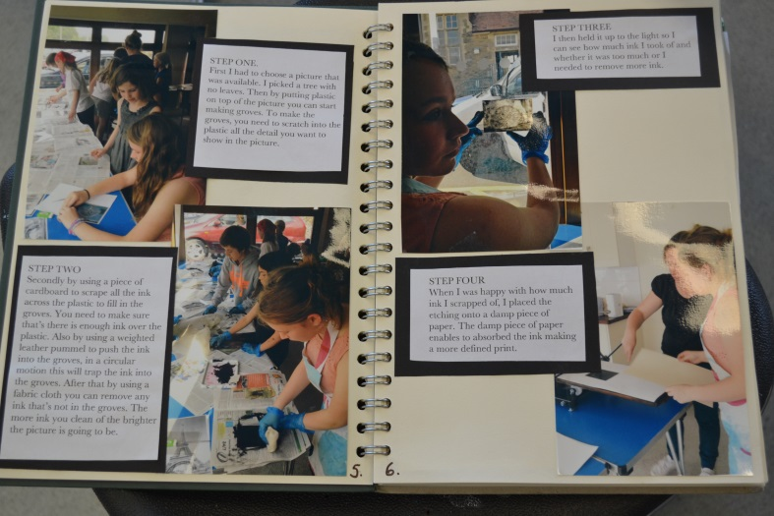
Director of the Arts
